Міністерство освіти і науки України

Національний університет «Запорізька політехніка»

кафедра програмних засобів

ЗВІТ

з лабораторної роботи № 1

з дисципліни «Кросплатфомне програмування» на тему:

**«Створення розподіленої системи на базі HTCondor»**

Виконав:

ст. гр. КНТ-113сп Іван Щедровський

Прийняв:

асистент Олександр КОРОТКИЙ

2024

# Мета роботи:

Навчитися розгортати та конфігурувати обчислювальний кластер на базі системи HTCondor.

# Хід виконання самостійної роботи:

Після запуску condor на трьох різних машинах було запущено скрипт командою “condor_submit submit.sub”, результат зображений на рисунку 2.1

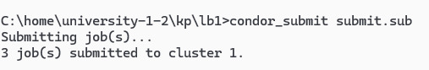

Рисунок 2.1 – Результат запуску submit

Далі було запущено команду для моніторингу “condor_q –sub ltlait”, результат зображений на рисунку 2.2

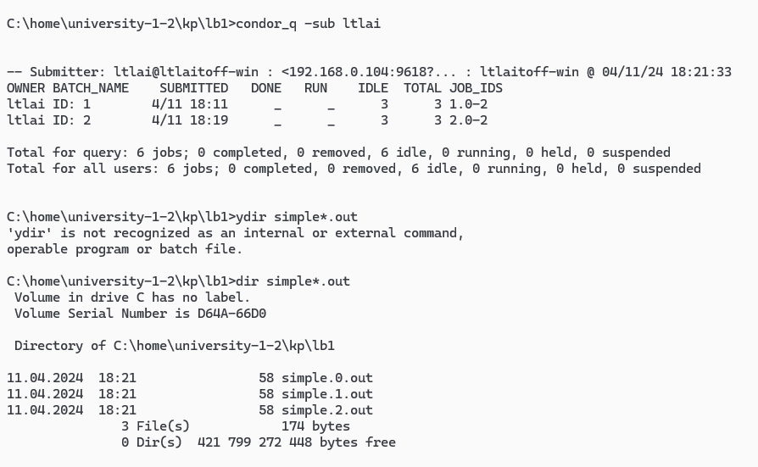

Рисунок 2.2 – Результат запуску condor_q -sub ltlait

В результаті в директорії з’явились додаткові файли. А саме файли .out, .log та .error. Директорія показана на рисунку 2.3.

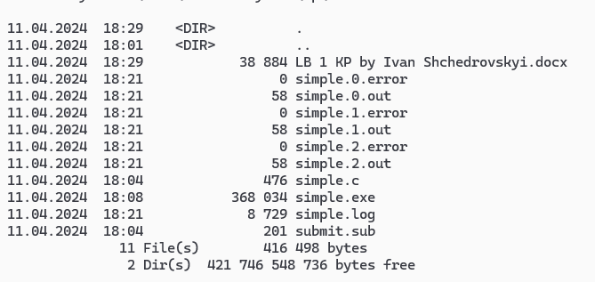

Рисунок 2.3 – Всі файли в директорії

Відображення результуючих файлів яке виконано командою dir simple*.out показано на рисунку 2.4.

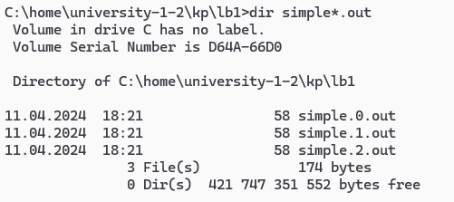

Рисунок 2.4 – Відображення результуючих файлів

Контент файлу simple.log(він занадто великий для фото):

000 (001.000.000) 2024-04-11 18:09:34 Job submitted from host: <192.168.0.104:9618?addrs=192.168.0.104-9618&alias=ltlaitoff-win&noUDP&sock=schedd_9824_8572>

...

000 (001.001.000) 2024-04-11 18:09:34 Job submitted from host: <192.168.0.104:9618?addrs=192.168.0.104-9618&alias=ltlaitoff-win&noUDP&sock=schedd_9824_8572>

...

000 (001.002.000) 2024-04-11 18:09:34 Job submitted from host: <192.168.0.104:9618?addrs=192.168.0.104-9618&alias=ltlaitoff-win&noUDP&sock=schedd_9824_8572>

...

000 (001.000.000) 2024-04-11 18:11:48 Job submitted from host: <192.168.0.104:9618?addrs=192.168.0.104-9618&alias=ltlaitoff-win&noUDP&sock=schedd_19596_5ada>

...

000 (001.001.000) 2024-04-11 18:11:48 Job submitted from host: <192.168.0.104:9618?addrs=192.168.0.104-9618&alias=ltlaitoff-win&noUDP&sock=schedd_19596_5ada>

...

000 (001.002.000) 2024-04-11 18:11:48 Job submitted from host: <192.168.0.104:9618?addrs=192.168.0.104-9618&alias=ltlaitoff-win&noUDP&sock=schedd_19596_5ada>

...

000 (002.000.000) 2024-04-11 18:19:00 Job submitted from host: <192.168.0.104:0?alias=ltlaitoff-win&sock=schedd_17540_b5de>

...

000 (002.001.000) 2024-04-11 18:19:00 Job submitted from host: <192.168.0.104:0?alias=ltlaitoff-win&sock=schedd_17540_b5de>

...

000 (002.002.000) 2024-04-11 18:19:00 Job submitted from host: <192.168.0.104:0?alias=ltlaitoff-win&sock=schedd_17540_b5de>

...

001 (001.002.000) 2024-04-11 18:21:46 Job executing on host: <192.168.0.104:9618?addrs=192.168.0.104-9618&alias=ltlaitoff-win&noUDP&sock=startd_10792_1ed4>

SlotName: slot1_3@ltlaitoff-win

CondorScratchDir = "C:\condor\execute\dir_11596"

Cpus = 1

Disk = 411929

Memory = 128

...

001 (002.000.000) 2024-04-11 18:21:46 Job executing on host: <192.168.0.104:9618?addrs=192.168.0.104-9618&alias=ltlaitoff-win&noUDP&sock=startd_10792_1ed4>

SlotName: slot1_4@ltlaitoff-win

CondorScratchDir = "C:\condor\execute\dir_10600"

Cpus = 1

Disk = 411929

Memory = 128

...

001 (001.001.000) 2024-04-11 18:21:46 Job executing on host: <192.168.0.104:9618?addrs=192.168.0.104-9618&alias=ltlaitoff-win&noUDP&sock=startd_10792_1ed4>

SlotName: slot1_2@ltlaitoff-win

CondorScratchDir = "C:\condor\execute\dir_13104"

Cpus = 1

Disk = 411929

Memory = 128

...

001 (002.002.000) 2024-04-11 18:21:46 Job executing on host: <192.168.0.104:9618?addrs=192.168.0.104-9618&alias=ltlaitoff-win&noUDP&sock=startd_10792_1ed4>

SlotName: slot1_6@ltlaitoff-win

CondorScratchDir = "C:\condor\execute\dir_19568"

Cpus = 1

Disk = 411929

Memory = 128

...

001 (001.000.000) 2024-04-11 18:21:46 Job executing on host: <192.168.0.104:9618?addrs=192.168.0.104-9618&alias=ltlaitoff-win&noUDP&sock=startd_10792_1ed4>

SlotName: slot1_1@ltlaitoff-win

CondorScratchDir = "C:\condor\execute\dir_3116"

Cpus = 1

Disk = 411929

Memory = 128

...

001 (002.001.000) 2024-04-11 18:21:46 Job executing on host: <192.168.0.104:9618?addrs=192.168.0.104-9618&alias=ltlaitoff-win&noUDP&sock=startd_10792_1ed4>

SlotName: slot1_5@ltlaitoff-win

CondorScratchDir = "C:\condor\execute\dir_19312"

Cpus = 1

Disk = 411929

Memory = 128

...

006 (001.000.000) 2024-04-11 18:21:46 Image size of job updated: 8936

9 - MemoryUsage of job (MB)

8936 - ResidentSetSize of job (KB)

...

006 (002.002.000) 2024-04-11 18:21:46 Image size of job updated: 15080

15 - MemoryUsage of job (MB)

15080 - ResidentSetSize of job (KB)

...

006 (001.002.000) 2024-04-11 18:21:46 Image size of job updated: 15072

15 - MemoryUsage of job (MB)

15072 - ResidentSetSize of job (KB)

...

006 (002.000.000) 2024-04-11 18:21:46 Image size of job updated: 15072

15 - MemoryUsage of job (MB)

15072 - ResidentSetSize of job (KB)

...

006 (001.000.000) 2024-04-11 18:21:46 Image size of job updated: 11620

12 - MemoryUsage of job (MB)

11620 - ResidentSetSize of job (KB)

...

006 (002.001.000) 2024-04-11 18:21:46 Image size of job updated: 15076

12 - MemoryUsage of job (MB)

11624 - ResidentSetSize of job (KB)

...

006 (001.001.000) 2024-04-11 18:21:46 Image size of job updated: 15068

15 - MemoryUsage of job (MB)

15068 - ResidentSetSize of job (KB)

...

005 (001.000.000) 2024-04-11 18:21:46 Job terminated.

(1) Normal termination (return value 0)

Usr 0 00:00:00, Sys 0 00:00:00 - Run Remote Usage

Usr 0 00:00:00, Sys 0 00:00:00 - Run Local Usage

Usr 0 00:00:00, Sys 0 00:00:00 - Total Remote Usage

Usr 0 00:00:00, Sys 0 00:00:00 - Total Local Usage

0 - Run Bytes Sent By Job

0 - Run Bytes Received By Job

0 - Total Bytes Sent By Job

0 - Total Bytes Received By Job

Partitionable Resources : Usage Request Allocated

Cpus : 1 1

Disk (KB) : 375 375 411929

Memory (MB) : 12 1 128

Job terminated of its own accord at 2024-04-11T15:21:46Z with exit-code 0.

...

005 (001.002.000) 2024-04-11 18:21:46 Job terminated.

(1) Normal termination (return value 0)

Usr 0 00:00:00, Sys 0 00:00:00 - Run Remote Usage

Usr 0 00:00:00, Sys 0 00:00:00 - Run Local Usage

Usr 0 00:00:00, Sys 0 00:00:00 - Total Remote Usage

Usr 0 00:00:00, Sys 0 00:00:00 - Total Local Usage

0 - Run Bytes Sent By Job

0 - Run Bytes Received By Job

0 - Total Bytes Sent By Job

0 - Total Bytes Received By Job

Partitionable Resources : Usage Request Allocated

Cpus : 1 1

Disk (KB) : 375 375 411929

Memory (MB) : 15 1 128

Job terminated of its own accord at 2024-04-11T15:21:46Z with exit-code 0.

...

005 (002.000.000) 2024-04-11 18:21:46 Job terminated.

(1) Normal termination (return value 0)

Usr 0 00:00:00, Sys 0 00:00:00 - Run Remote Usage

Usr 0 00:00:00, Sys 0 00:00:00 - Run Local Usage

Usr 0 00:00:00, Sys 0 00:00:00 - Total Remote Usage

Usr 0 00:00:00, Sys 0 00:00:00 - Total Local Usage

0 - Run Bytes Sent By Job

0 - Run Bytes Received By Job

0 - Total Bytes Sent By Job

0 - Total Bytes Received By Job

Partitionable Resources : Usage Request Allocated

Cpus : 1 1

Disk (KB) : 375 375 411929

Memory (MB) : 15 1 128

Job terminated of its own accord at 2024-04-11T15:21:46Z with exit-code 0.

...

005 (002.001.000) 2024-04-11 18:21:46 Job terminated.

(1) Normal termination (return value 0)

Usr 0 00:00:00, Sys 0 00:00:00 - Run Remote Usage

Usr 0 00:00:00, Sys 0 00:00:00 - Run Local Usage

Usr 0 00:00:00, Sys 0 00:00:00 - Total Remote Usage

Usr 0 00:00:00, Sys 0 00:00:00 - Total Local Usage

0 - Run Bytes Sent By Job

0 - Run Bytes Received By Job

0 - Total Bytes Sent By Job

0 - Total Bytes Received By Job

Partitionable Resources : Usage Request Allocated

Cpus : 1 1

Disk (KB) : 375 375 411929

Memory (MB) : 12 1 128

Job terminated of its own accord at 2024-04-11T15:21:46Z with exit-code 0.

...

005 (002.002.000) 2024-04-11 18:21:46 Job terminated.

(1) Normal termination (return value 0)

Usr 0 00:00:00, Sys 0 00:00:00 - Run Remote Usage

Usr 0 00:00:00, Sys 0 00:00:00 - Run Local Usage

Usr 0 00:00:00, Sys 0 00:00:00 - Total Remote Usage

Usr 0 00:00:00, Sys 0 00:00:00 - Total Local Usage

0 - Run Bytes Sent By Job

0 - Run Bytes Received By Job

0 - Total Bytes Sent By Job

0 - Total Bytes Received By Job

Partitionable Resources : Usage Request Allocated

Cpus : 1 1

Disk (KB) : 375 375 411929

Memory (MB) : 15 1 128

Job terminated of its own accord at 2024-04-11T15:21:46Z with exit-code 0.

...

005 (001.001.000) 2024-04-11 18:21:46 Job terminated.

(1) Normal termination (return value 0)

Usr 0 00:00:00, Sys 0 00:00:00 - Run Remote Usage

Usr 0 00:00:00, Sys 0 00:00:00 - Run Local Usage

Usr 0 00:00:00, Sys 0 00:00:00 - Total Remote Usage

Usr 0 00:00:00, Sys 0 00:00:00 - Total Local Usage

0 - Run Bytes Sent By Job

0 - Run Bytes Received By Job

0 - Total Bytes Sent By Job

0 - Total Bytes Received By Job

Partitionable Resources : Usage Request Allocated

Cpus : 1 1

Disk (KB) : 375 375 411929

Memory (MB) : 15 1 128

Job terminated of its own accord at 2024-04-11T15:21:46Z with exit-code 0.

...

А також на рисунку 2.5 показаний контент кожного .out файлу.

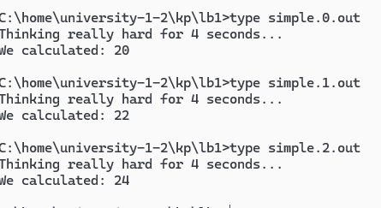

Рисунок 2.5 – Показ контенту кожного .out файлу

Після перегляду результуючих файлів можно зробити висновок, що програма працює коректо значення аргументів помножених на 2 підраховано вірно, та затримка перед виконанням наступного аргументу була 4 секунди.

# Висновки:

Я навчився розгортати та конфігурувати обчислювальний кластер на базі системи HTCondor.